Riddle Book Rubric -Student Rubric
Category |  |  |  | 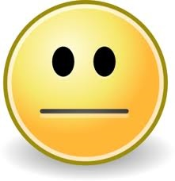
Riddles | All riddles were completed without help. | Most riddles were completed without help. | Some riddles were completed without help. | No riddles were completed without help.
Facts about Community Helper | You used three or more facts about your community helper without help. | You wrote two facts about your community helper without help. | You wrote one fact about your community helper without help. | You couldn’t think of a fact to write about your community helper on your own.
Spelling | You tried your best to spell and recognize all sounds in words. | You were able to spell and recognize most sounds in words. | You were able to spell and recognize some sounds in words. | You didn’t quite understand how to spell out your words.
Name and Picture of Community Helper | You wrote the name and drew a colorful picture of your community helper. | You wrote the name and drew a picture of your community helper using little or no color. | You either wrote the name of your community helper or drew a picture but not both. | You didn’t put the community helper’s name or draw a picture.

